Real-Time Communication System Powered by AI for Specially Abled

Submitted By

**TEAM ID : PNT2022TMID25445**

**TEAM LEADER : LOGESH G - 210819106033**

**TEAM MEMBERS : LINGAKUMAR M - 210819106032**

**BALAJI P – 210819106007**

**HARISH S - 210819106017**

**Project Report Format**

## INTRODUCTION

* 1. Project Overview
  2. Purpose

## LITERATURE SURVEY

* 1. Existing problem
  2. References
  3. Problem Statement Definition

## IDEATION & PROPOSED SOLUTION

* 1. Empathy Map Canvas
  2. Ideation & Brainstorming
  3. Proposed Solution
  4. Problem Solution fit

## REQUIREMENT ANALYSIS

* 1. Functional requirement
  2. Non-Functional requirements

## PROJECT DESIGN

* 1. Data Flow Diagrams
  2. Solution & Technical Architecture
  3. User Stories

## PROJECT PLANNING & SCHEDULING

* 1. Sprint Planning & Estimation
  2. Sprint Delivery Schedule
  3. Reports from JIRA

### CODING & SOLUTIONING (Explain the features added in the project along with code)

* 1. Feature 1
  2. Feature 2
  3. Database Schema (if Applicable)

## TESTING

* 1. Test Cases
  2. User Acceptance Testing

## RESULTS

* 1. Performance Metrics

1. **ADVANTAGES & DISADVANTAGES**
2. **CONCLUSION**
3. **FUTURE SCOPE**
4. **APPENDIX**

Source Code, GitHub & Project Demo Link

## INTRODUCTION

* 1. **Project Overview**

Real-time communications (RTC) are any mode of telecommunications in which all users can exchange information instantly. Communication plays a significant role in making the world better place. It creates a bonding and relations among the people. People get to know one another by sharing their ideas, thoughts, and experiences with those around them. There are numerous ways to accomplish this, the best of which is the gift of "Speech." Everyone can very convincingly transfer their thoughts and understand each other through speech. It will be unjust if we overlook those who are denied this priceless gift: the deaf and dumb. In such cases, the human hand has remained the preferred method of communication.

### Purpose

The Project's purpose is to create a system that translates sign language into a human understandable language so that ordinary people may understand it. In our society, we have people with disabilities. The technology is developing day by day but no significant developments are undertaken for the betterment of these people. Communications between deaf-mute and a normal person has always been a challenging task. It is very difficult for mute people to convey their message to normal people. Since normal people are not trained on hand sign language. In emergency times conveying their message is very difficult. The human hand has remained a popular choice to convey information in situations where other forms like speech cannot be used. Voice Conversion System with Hand Gesture Recognition and translation will be very useful to have a proper conversation between a normal person and an impaired person in any language. The project aims to develop a system that converts the sign language into a human hearing voice in the desired language to convey a message to normal people, as well as convert speech into understandable sign language for the deaf and dumb. We are making use of a convolution neural network to create a model that is trained on different hand gestures. An app is built which uses this model. This app enables deaf and dumb people to convey their information using signs which get converted to human-understandable language and speech is given as output.

## LITERATURE SURVEY

A literature review is **a comprehensive summary of previous research on a topic**. The literature review surveys scholarly articles, books, and other sources relevant to a area of research. The review should enumerate, describe, summarize,objectively evaluate and clarify this previous research.

In our project, We have taken the literature survey on IEEE papers. An intelligent communication device is developed to assist nonverbal, motor-disabled persons in the generation of written and spoken messages. The device is centered on knowledge base of the grammatical rules and message elements. A belief reasoning scheme based on both the information from external sources and the embedded knowledge issued to optimize the process of message search

### 2.1 Existing problem

Some of the existing solutions for solving this problem are:

Communications between deaf-mute and a normal person has always been a challenging task.It is very difficult for mute people to convey their message to normal people.

### Technology

One of the easiest ways to communicate is through technology such as a phone or laptop. A deaf person can type out what they want to say and a person who is blind orhas low vision can use a screen reader to read the text out loud.

A blind person can alsouse voice recognition software to convert what they are saying in to text so that a person who is Deaf can then read it.

### Interpreter

If a sign language interpreter is available, this facilitates easy communication if the person who is deaf is ﬂuent in sign language. The deaf person and person who is blindcan communicate with each other via the interpreter. The deaf person can use sign language and the interpreter can speak what has been said to the person who is blind and then translate anything spoken by the blind person into sign language for the deaf person.

However, this is often not the most effective form of communication, as it is very dependent on the individual circumstances of both people and their environment (for

example, some places may have too much background noise).

### 2.2 References

1. Upendran, S., and Thamizharasi, A., "American Sign Language interpreter system for deaf and dumb individuals”, In the Proceedings of the International Conference on Control, Instrumentation, Communication and Computational Technologies (ICCICCT), pp. 1477- 1481, 2014
2. Lotti, F.,Tiezzi, P., Vassura, G.,Biagiotti, L., and Melchiorri, C., "UBH 3: an anthropomorphic hand with simplified endo-skeletal structure and soft continuous fingerpads", In Proceedings IEEE International Conference on Robotics and Automation, 2004 (ICRA'04), Vol.5, pp. 4736-474, IEEE, 2004.
3. Rajamohan, A., Hemavathy, R., andDhanalakshmi, M., “Deaf-Mute Communication

Interpreter”, International Journal of Scientific Engineering and Technology, Vol.2, No.5,

pp.336-341, 2013.

https://ieeexplore.ieee.org/document/8493808

<https://ieeexplore.ieee.org/abstract/document/9396030>

https://ieeexplore.ieee.org/document/8725244

### 2.3 Problem statement deﬁnition

Only specially abled people are taught sign language and the common person is unaware its working causing a communication gap. Under emergency situations, it is even more difficult for specially abled people to get help. Non-Emergency normal environments can also be hard for them to navigate needing special assistance. In this project we have designed and developed a system which lowers the communication gap betweenspeech hearing impaired people and normal people that is we have built a system that enables communications between deaf-dumb person and a normal person. A convolution neural network is being used to develop a model that is trained on varioushand movements. This model is used to create an app. This program allows deaf and hard of hearing persons to communicate using signs that are then translated into human readable text.

## IDEATION AND PROPOSED SOLUTION

Ideation is the process where you generate ideas and solutions through techniques such as Empathy Map Canvas, Brainstorming. Ideation is also the third stage in the Design Thinking Process.

* 1. **3.1 Empathy map canvas**

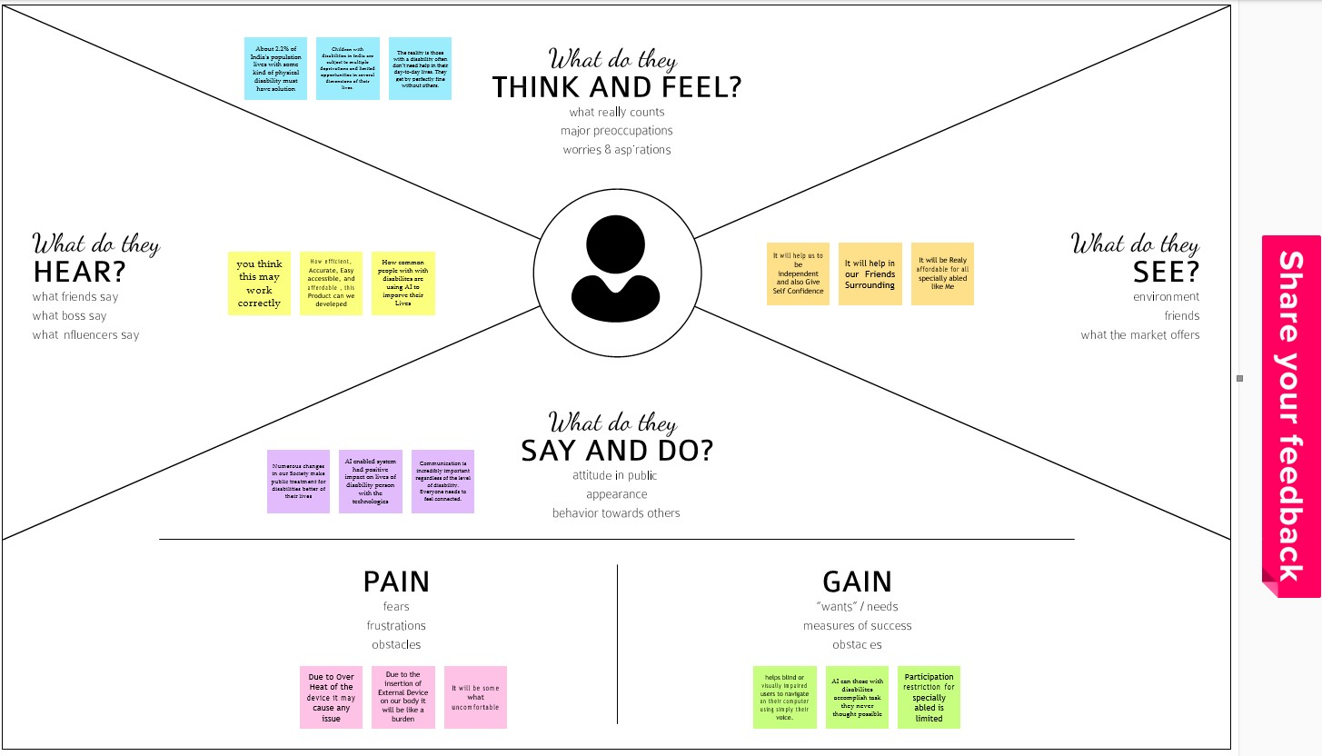

* 1. **3.2 Ideation & Brainstorming**

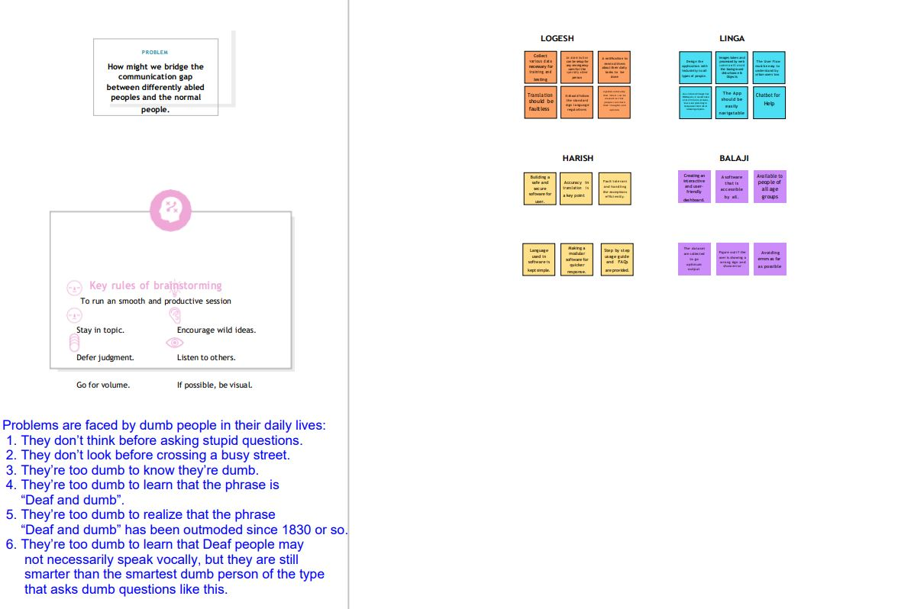

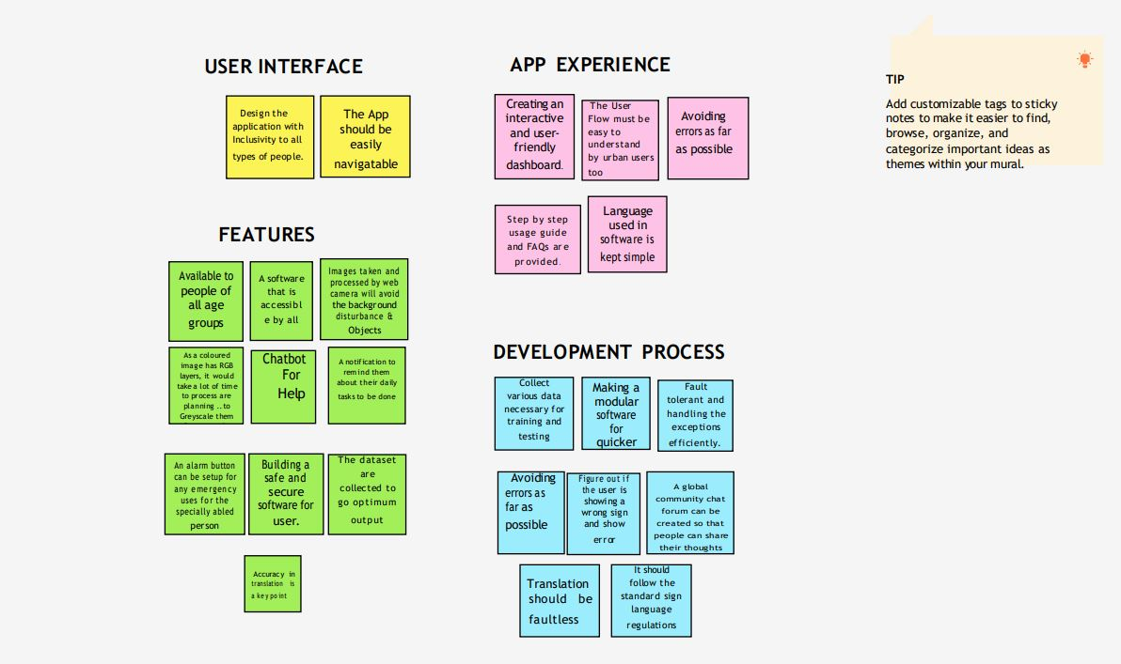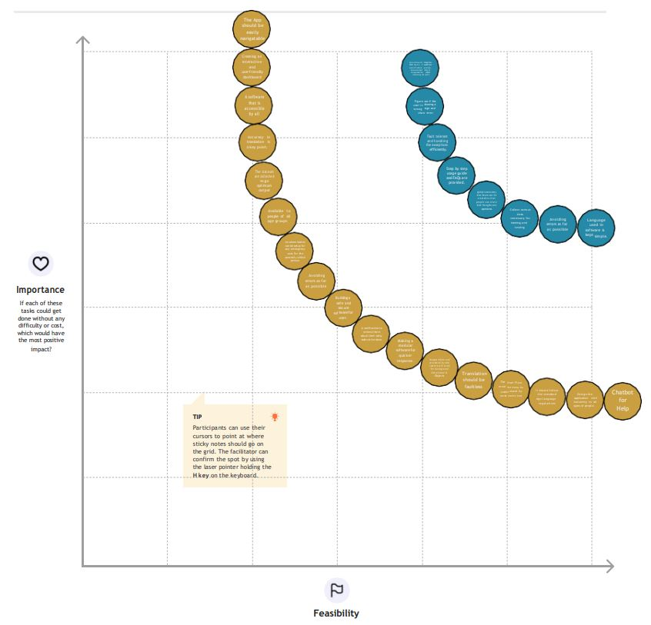

**3.3 Proposed Solution**

**Proposed Solution Template:**

|  |  |  |
| --- | --- | --- |
| **S.No** | **Parameter** | **Description** |
| 1. | Problem Statement (Problem to besolved) | Sign Language is a visual means of communicating using gestures, facial expressions, and body language with specially abled. Since normal people are not trained in sign language, in times of emergency conveyingtheir message is very difficult. Hence, there is a need for a system that recognizes different signs and empowers them in communicating  with normal people |
| 2. | Idea / Solution description | The idea is to create an end-end application that predicts the ISL signs from a live video andtranslates the same to voice such that  conversing is at ease |
| 3. | Novelty / Uniqueness | We are making use of a convolution neural network to create a model that is trained on  different hand gestures. |
| 4. | Social Impact / Customer Satisfaction | * Communication is achieved without the help of additional human intervention. * No additional hardware support is needed to use the application * Improve their career opportunities in the industry * Can provide instant results to users |

|  |  |  |
| --- | --- | --- |
| 5. | Business Model (Revenue Model) | This business model truly revolutionizes accessibility and people with disabilities can drastically improve their everyday lives.  We can associate the application with organizations to provide support for the specially abled. Creating an association withother medical applications to utilize our  product in their app. |
| 6. | Scalability of the Solution | This is a application people can access the application from any device (Mobile, Desktop, laptop, etc.), and used by everyone across the world. As it is hosted in IBM Cloud, it could be scaled up and down as per deman |

Proposed solution is the one in which we are making use of a convolution neural network to create a model that is trained on different hand gestures. A website is built which uses this model. The proposed solution section should offer the solution speciﬁcally, with enough detail so that the reader understands exactly what we're proposing.

### 3.4 Problem solution ﬁt:

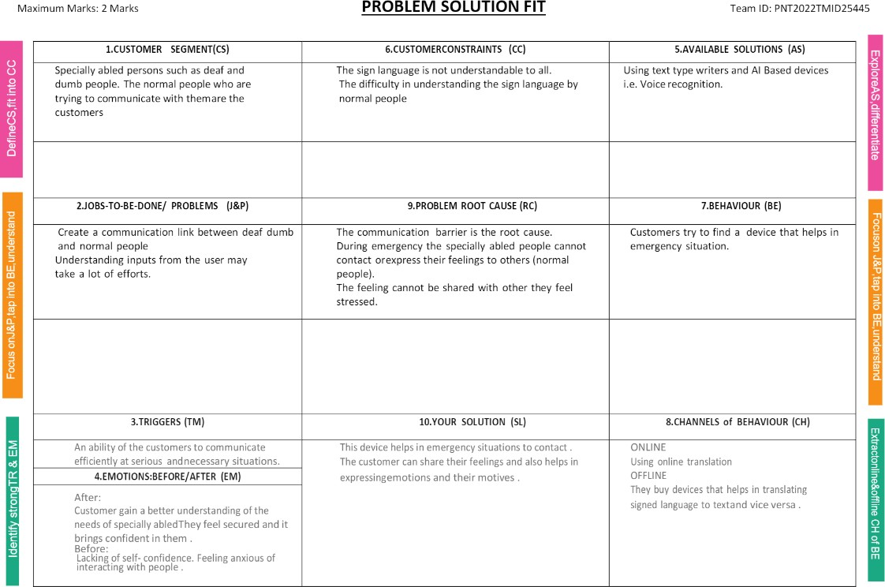

The Problem-Solution Fit is based on the principles of Lean Startup and User Experience design. It helps us to identify behavioral patterns and recognize what would work and why. It is used to identify solutions with higher chances of solution adoption, reduce time spent on testing.

## REQUIREMENT ANALYSIS

### 4.1 Functional requirement:

Following are the functional requirements of the proposed solution.

|  |  |  |
| --- | --- | --- |
| **FR No.** | **Functional Requirement (Epic)** | **Sub Requirement (Story / Sub-Task)** |
| FR-1 | User Registration | Registration through Form Registration through Gmail  Registration through LinkedIN |
| FR-2 | User Confirmation | Confirmation via Email Confirmation  via OTP |
| FR-3 | User Verification | The user should receive a verification e-mail which theyhave to confirm to complete the registration. |
| FR-4 | Compliance to rules or laws | Terms and conditions, Privacy policy, End user licensing  agreement. |
| FR-5 | Authorization levels | There are two levels of authorization namely standard access level and advanced access level. |
| FR-6 | Legal Requirements | Medical Certificate is produced |

### 4.2 Non Functional requirement:

Following are the non-functional requirements of the proposed solution.

|  |  |  |
| --- | --- | --- |
| **FR No.** | **Non-Functional Requirement** | **Description** |
| NFR-1 | **Usability** | The designed system is easy to use for speciallyabled persons as it is portable and  platform independent. |
| NFR-2 | **Security** | Converted information using signs into speech is accessed only by the user. |
| NFR-3 | **Reliability** | System is tested with large number of data and Providesinsight into issues. |
| NFR-4 | **Performance** | Quick Launch time of application and faster in converting signs into speech |
| NFR-5 | **Availability** | Provides automatic recovery and  User access. |
| NFR-6 | **Scalability** | Standard network condition the device should convert information within second. |

## PROJECT DESIGN

Project design is an early phase of the project lifecycle where ideas, processes,

resources, and deliverables are planned out. A project design comes before a projectplan as it's a broad overview whereas a project plan includes more detailed information.

### 5.1 Data Flow Diagrams

A data ﬂow diagram is a traditional visual representation of the information ﬂow within a system. It shows how data enters and leaves the system. It uses deﬁned symbols like rectangles, circles and arrows, plus short text labels, to show data inputs, outputs, storage points and the routes between each destination.

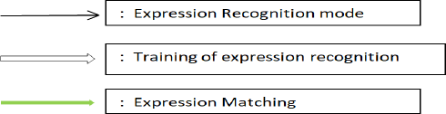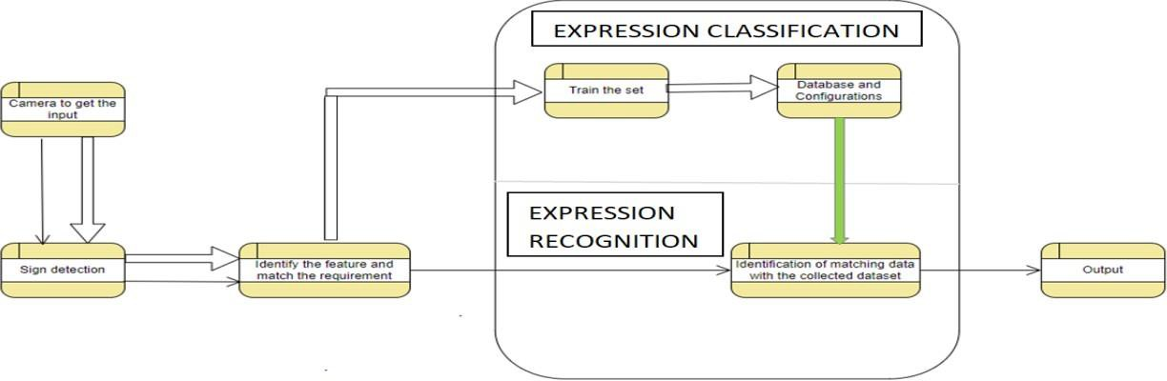

### 5.2 Solution Architecture & Technical Architecture

### Solution Architecture:

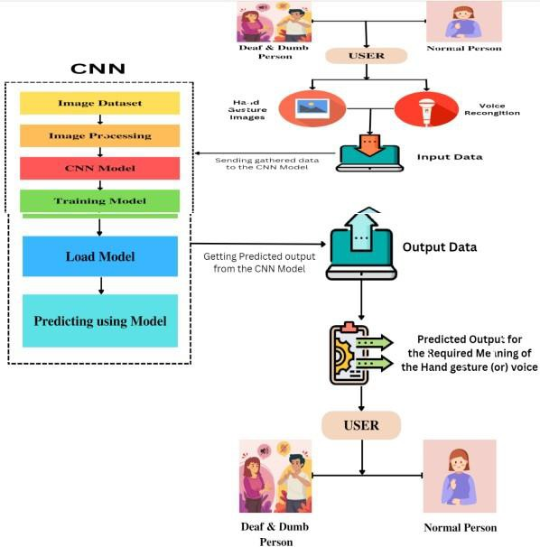

Solution architecture is the process of developing solutions based on predeﬁned processes, guidelines and best practices with the objective that the developed solution ﬁts within the enterprise architecture in terms of information architecture, system portfolios, integration requirements and many more.

### Technical Architecture:

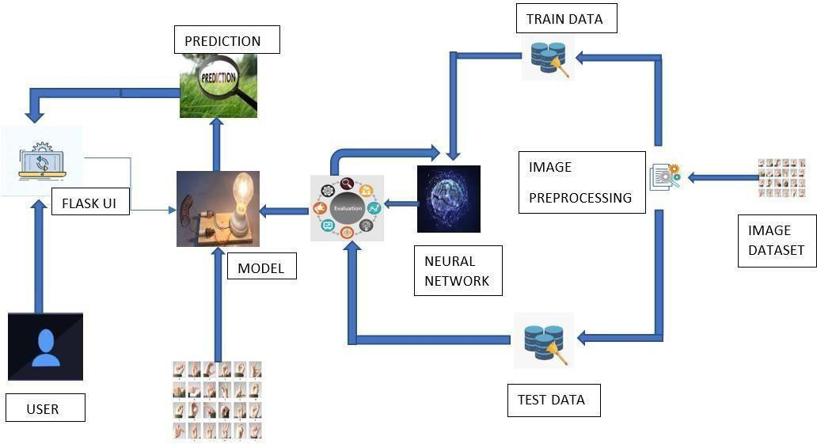

Technical Architecture is a form of Information Technology(IT) architecture that is used to design a system. It involves the development of a technical blueprint with regard to the arrangement, interaction, and interdependence of all elements so that system- relevant requirements are met.

### Table-1: Components & Technologies:

|  |  |  |  |
| --- | --- | --- | --- |
| **S.No** | **Component** | **Description** | **Technology** |
| 1. | User Interface | Chat bot user interface | HTML, CSS, Python. |
| 2. | Application Logic | Logic for a process in the application | Python |
| 3. | Application Logic | Logic for a process in the application | IBM Watson STT service & TTS service |
| 4. | Cloud Database | Database Service on Cloud | IBM Cloudant |

|  |  |  |  |
| --- | --- | --- | --- |
| 5. | File Storage | File storage requirements | Local File system |
| 6. | Machine  Learning Model | Neural Networks –CNN model, ANN model | Object Recognition Model – CNNmodel |
| 7. | Infrastructure (Server / Cloud) | Application Deployment on Local System | Local, Cloud Foundry, Kubernetes. |
| 8. | External Interfaces | Any interface that is transmitting information from the product to a third-party may contain informationthat is useful for an attack | Operating System - Windows, Mac, Linux; CPU & GPU (for training), WebCam, Scanners, Speakers  and PC |

**Table-2: Application Characteristics:**

|  |  |  |  |
| --- | --- | --- | --- |
| **S.No** | **Characteristics** | **Description** | **Technology** |
| 1. | Open-Source Frameworks | Numpy, Pandas , Keras,  Tensorflow, NLTK,Sonnet. | Python framework |
| 2. | Security Implementations | Security access controls ,Use of  firewalls | SHA-256 |
| 3. | Scalable Architecture | Scalable AI | SEI Digital library |
| 4. | Availability | Use of Cloud, Virtual assistant | IBM Cloud  IBM Watson Assistant |
| 5. | Performance | Image pre-processing and CNN | Python |

User Stories:

|  |  |  |  |  |  |  |
| --- | --- | --- | --- | --- | --- | --- |
| User Type | Functional Requiremen t  (Epic) | User Story Number | User Story / Task | Acceptance criteria | Priority | Release |
| Normal people and Deaf- mute people | Registration | USN-1 | As a user, I can register for the application by entering my email, and password, and confirming my password | I can access my  account/  dash boar d | High | Sprint-1 |
|  |  | USN-2 | As a user, I will receive a confirmation email once I have registered for the application | I can receive confirmation email & click confirm | High | Sprint-1 |

|  |  |  |  |  |  |  |
| --- | --- | --- | --- | --- | --- | --- |
| Normal people |  | USN-3 | Give access to camera to recognize the gestures  Give access to microphone to give our message through voice | I can access messages given by the Deaf- mute people | High | Sprint-1 |
| Deaf- mute peopl e |  |  | Give access to display to view the message sent by normal people. | I can access messages given  by the Norma l  people | High | Sprint-1 |
| Administrator |  | USN-4 | Admin side in the company should take care | all the requireme nts are  there. | High | Sprint 1 |
| Sign up |  | USN-5 | Need to sign up to use it. | Need valid credentials. | High | Sprint-1 |
| Wish list |  | USN-6 | Before availing the service can be kept aside. | As a user can review anduse the  service. | Low | Sprint-2 |

A user story is an informal, general explanation of a design feature written from the perspective of the end user. Its purpose is to articulate how a design will provide value to the end user. A key component of agile software development is putting people ﬁrst, and a user story puts end users at the center of the conversation. These stories use non-technical language to provide context for the development team and their efforts.

## PROJECT PLANNING & SCHEDULING

Planning and scheduling are distinct but inseparable aspects of managing the successful project. The process of planning primarily deals with selecting the appropriate policies and procedures in order to achieve the objectives of the project.Scheduling converts the project action plans for scope, time cost and quality into anoperating timetable.

### Sprint Planning & Estimation

To create product backlog and sprint schedule

|  |  |  |  |  |  |  |
| --- | --- | --- | --- | --- | --- | --- |
| **Sprint** | **Functional Requirement**  **(Epic)** | **User Story**  **Number** | **User Story / Task** | **Story Points** | **Priority** | **Team Members** |
| Sprint-1 | Registration | USN-1 | As a user, I can register for the application by entering my email, password, and confirming my password. | 2 | High | Logesh Lingakumar |
| Sprint-1 | Registration | USN-2 | As a user, I will receive confirmation emailonce I have registered for the  application | 1 | High | Balaji Harish |
| Sprint-2 | Registration | USN-3 | As a user, I can register for the application through  phone number | 2 | Mediu m | Lingakumar |
| Sprint-2 | User interface | USN-4 | Professional responsible for user requirements &  needs | 2 | Mediu m | Balaji Harish |
| Sprint-3 | Login | USN-5 | As a user, I can log into the applicationby entering email & password | 1 | High | Logesh |
| Sprint-3 | Dashboard | USN-6 | As a user, I must receive any updates orpop ups in  my dashboard | 2 | High | Lingakumar Balaji |
| Sprint-4 | Details | USN-7 | As a user, I should get notification about  the progress and any updates via email orsms | 1 | Mediu m | Harish |
| Sprint-4 | Privacy | USN-8 | The developed application should be secure forthe users | 2 | High | Lingakumar Logesh |

Sprint planning & Estimation is the process for estimating the effort required to complete a prioritized task in the product backlog. This effort is usually measured withrespect to the time it will take to complete that task, which, in turn, leads to accurate sprint planning.

### 6.2 Sprint Delivery Schedule

**Project Tracker, Velocity & Burndown Chart: (4 Marks)**

|  |  |  |  |  |  |  |
| --- | --- | --- | --- | --- | --- | --- |
| **Sprint** | **Total Story Points** | **Duration** | **Sprint Start Date** | **Sprint End Date (Planned)** | **Story Points Completed (as on Planned**  **End Date)** | **Sprint Release Date (Actual)** |
| Sprint-1 | 20 | 6 Days | 24 Oct 2022 | 29 Oct 2022 | 20 | 30 Oct 2022 |
| Sprint-2 | 20 | 6 Days | 31 Oct 2022 | 05 Nov 2022 | 20 | 05 Nov 2022 |
| Sprint-3 | 20 | 6 Days | 07 Nov 2022 | 12 Nov 2022 | 20 | 13 Nov 2022 |
| Sprint-4 | 20 | 6 Days | 14 Nov 2022 | 19 Nov 2022 | 20 | 29 Nov 2022 |

Since sprints take place over a ﬁxed period of time, it’s critical to avoid wasting time [during](https://www.plutora.com/solutions/use-cases/scaled-agile-framework-safe) [planning and development](https://www.plutora.com/solutions/use-cases/scaled-agile-framework-safe).

**6.3 Reports from JIRAROADMAP**

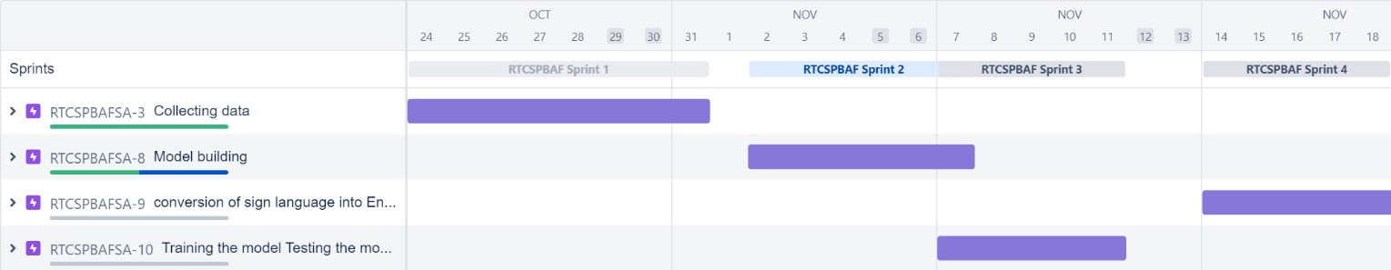

**Sprint-1**

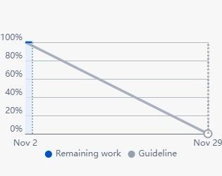

**Sprint-2**

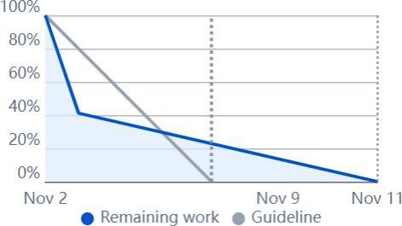

**Sprint-3**

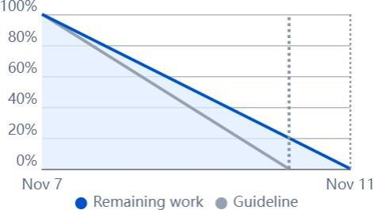

**Sprint-4**

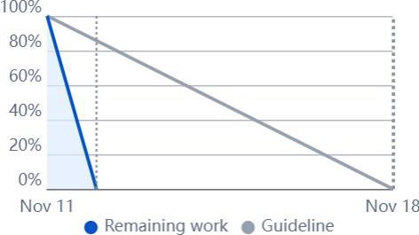

This are the ﬁnal reports that is been generated from the jira software. Initially with the help of the jira software we have made a plan for the sprint delivery. By using it so we are getting the four phase sprint report with roadmap.

## CODING & SOLUTIONING

In order to design website that coverts sign language into English alphabets we need to develop the website.For developing the website, primarly we need a platform that is uesful for developing the code.Coding is nothing that which are the applications developed by the developers in a certain computer language.Here we are using Python language for developing the website.

* 1. **Feature 1**

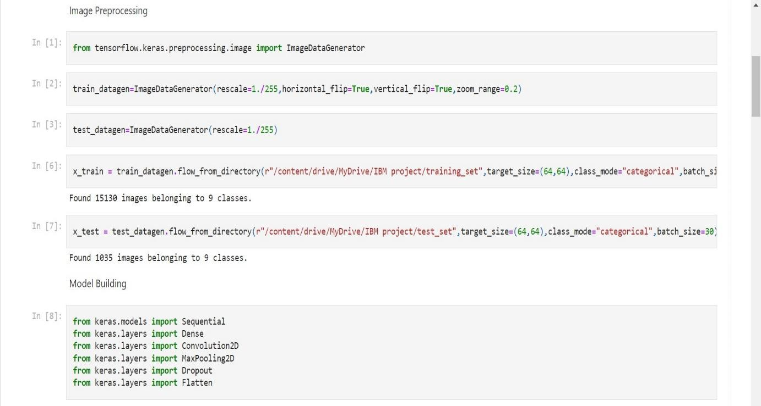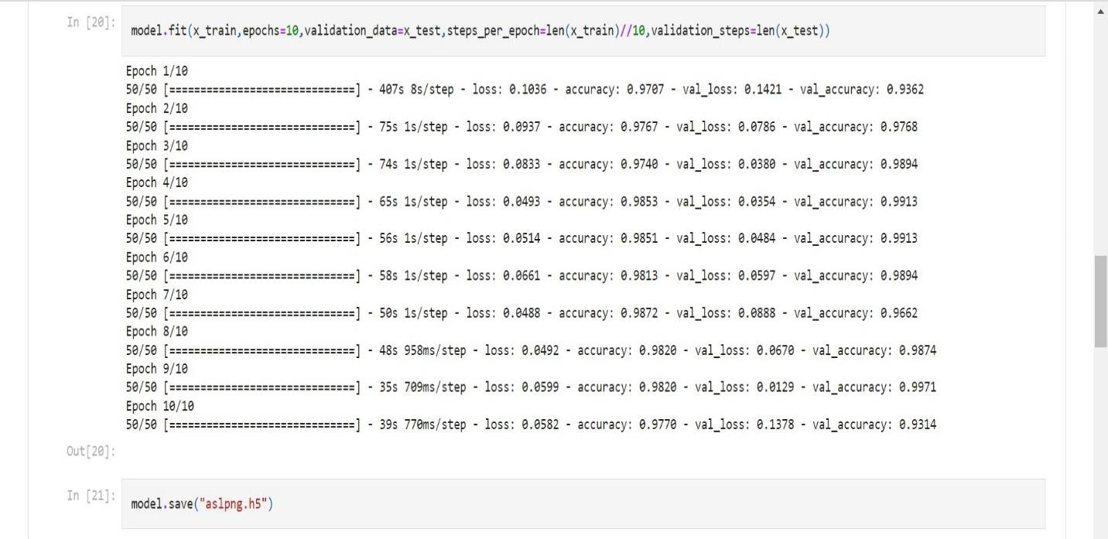

* 1. **Feature 2**

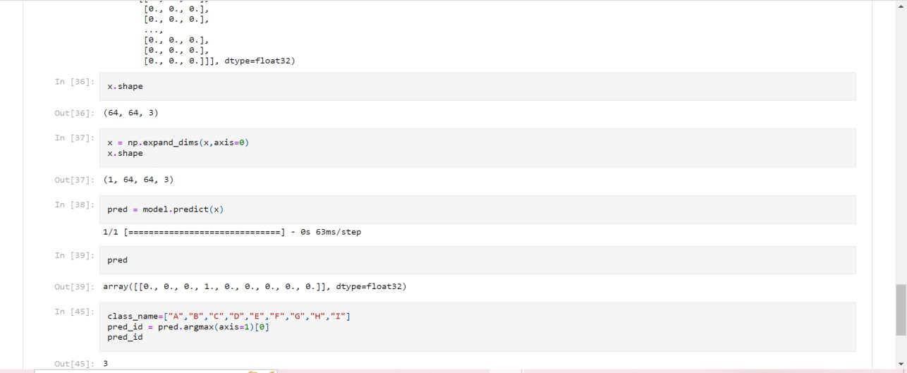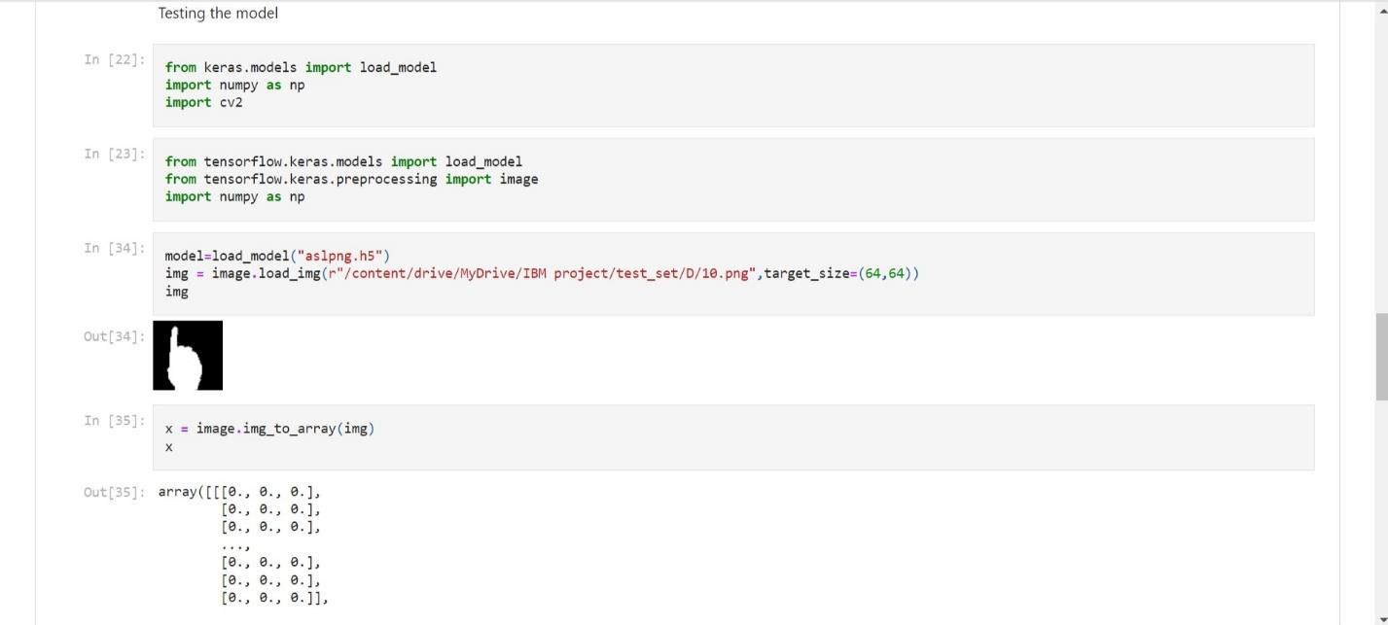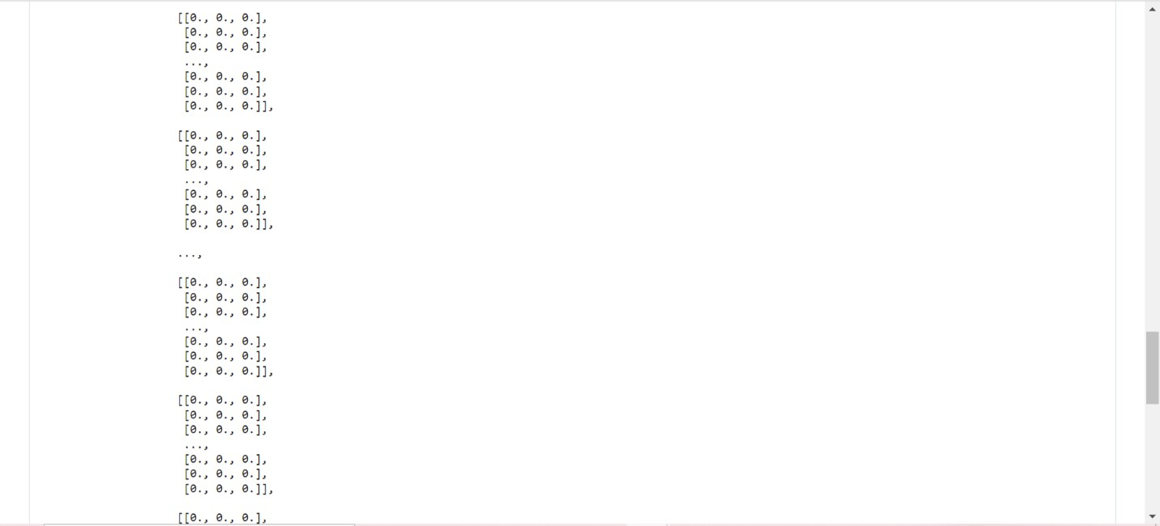

## TESTING

A Test report is an organized summary of testing objectives, activities, and results. Test Report is a document which contains a summary of all test activities and ﬁnal test results of a design. Test report is an assessment of how well the Testing is performed. Based on the test report, we understand the designs quality and its performance.

### 8.1 Test cases

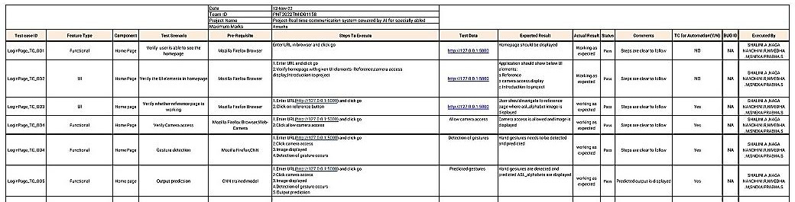

A test case is nothing but a series of step executed on a design, using a predeﬁned set of input data, expected to produce a pre-deﬁned set of outputs, in a given environment. It describes “how” to implement those test cases.

### 8.2 User Acceptance Testing

User acceptance testing (UAT), also called application testing or end-user testing, is a phase of software development in which the software is tested in the real world by its intended audience.

1. **Purpose of Document**

The purpose of this document is to briefly explain the test coverage and open issues of project-Real Time Communication System Powered By AI For Specially Abled at the time of the release to User Acceptance Testing (UAT).

1. **Defect Analysis**

This report shows the number of resolved or closed bugs at each severity level, and how they were resolved.

|  |  |  |  |  |  |
| --- | --- | --- | --- | --- | --- |
| **Resolution** | **Severity 1** | **Severity 2** | **Severity 3** | **Severity 4** | **Subtotal** |
| By Design | 0 | 0 | 0 | 2 | 2 |
| Duplicate | 1 | 0 | 0 | 0 | 1 |
| External | 0 | 0 | 1 | 0 | 1 |
| Fixed | 0 | 1 | 1 | 0 | 2 |
| Not Reproduced | 0 | 1 | 0 | 0 | 1 |
| Skipped | 0 | 0 | 0 | 0 | 0 |
| Won't Fix | 0 | 1 | 0 | 0 | 1 |
| Totals | 1 | 3 | 2 |  | 8 |

1. **Test Case**

Analysis This report shows the number of test cases that have passed, failed, and untested

|  |  |  |  |  |
| --- | --- | --- | --- | --- |
| **Section** | **Total Cases** | **Not Tested** | **Fail** | **Pass** |
| View Home Page | 7 | 0 | 1 | 6 |
| Click Reference | 15 | 0 | 3 | 12 |
| Image displayed | 12 | 0 | 0 | 12 |
| Allow camera access | 11 | 0 | 2 | 9 |
| PrintEngine | 8 | 0 | 0 | 8 |
| ClientApplication | 49 | 0 | 0 | 49 |
| Security | 4 | 0 | 0 | 4 |
| OutsourceShipping | 4 | 0 | 0 | 4 |
| ExceptionReporting | 11 | 0 | 0 | 11 |
| FinalReportOutput | 2 | 0 | 0 | 2 |
| VersionControl | 1 | 0 | 0 | 1 |

## RESULT

Finally we got the output for the desired input.our ultimate aim is to covert sign language into English alphanets.We have created the user interface for impleting it so.Thus the website was created successfully.As a result both the deaf and dump alongwith normal people can able to understand the desired language that is required for them.

### 9.1 Performance metrics

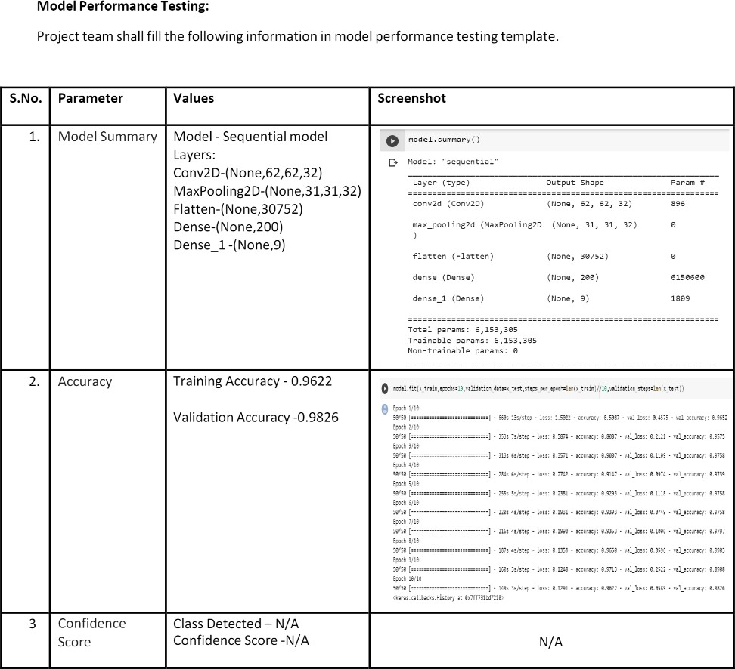

The proposed procedure was implemented and tested with set of images. The set of15750 images of Alphabets from “A” to “I” are used for training database and a set of 2250 images of Alphabets from “A” to “I” are used for testing database. Once the gesture is recognize the equivalent Alphabet is shown on the screen.

## ADVANTAGES & DISADVANTAGES

### Advantages:

1. Create a mobile application to bridge the communication gap between deaf and dumb persons and the general public.
2. Sign language standards exist, their dataset can be added, and the usercan choose which sign language to read.

### Disadvantages:

1. Model only works from alphabets A to I.
2. Absence of gesture recognition, alphabets from J cannot be identiﬁed.
3. As the quantity/quality of images in the dataset is low, the accuracy is not great.

## CONCLUSION

Sign language is a useful tool for facilitating communication between deaf and hearing people. Because it allows for two-way communication, the system aims to bridge the communication gap between deaf people and the rest of society.The proposed methodology translates language into English alphabets that are understandable to humans. This system sends hand gestures to the model, who recognises them and displays the equivalent Alphabet on the screen. Deaf-mute peoplecan use their hands to perform sign language, which will then be converted into alphabets, thanks to this project.

## FUTURE SCOPE

Having a technology that can translate hand sign language to its corresponding alphabet is a game changer in the ﬁeld of communication and AI for the specially abledpeople such as deaf and dumb. With introduction of gesture recognition, the web app can easily be expanded to recognize letters beyond 'I', digits and other symbols plus

gesture recognition can also allow controlling of software/hardware interfaces.

We can develop a model for ISL word and sentence level recognition. This will require a system that can detect changes with respect to the temporal space. We can also

develop a complete product that will help the speech and hearing-impaired people, andthereby reduce the communication gap.

## APPENDIX

Source Code for Model Training and Saving:

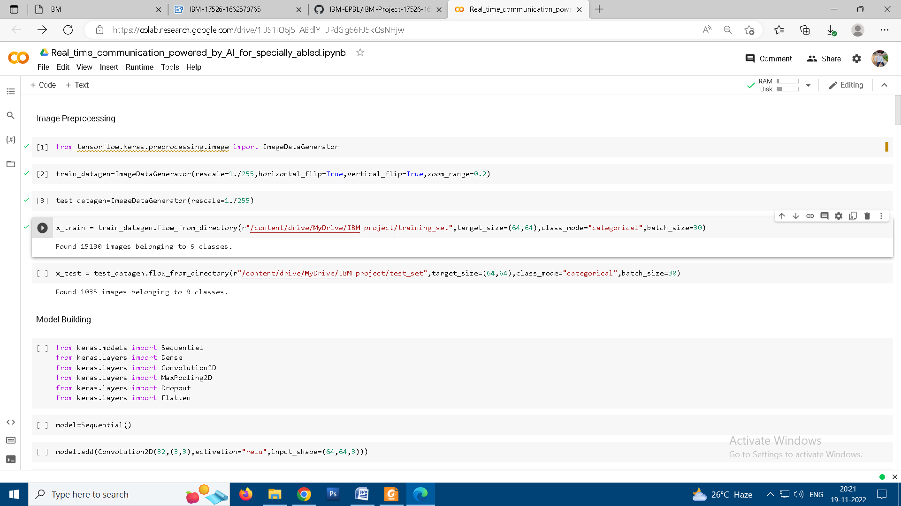

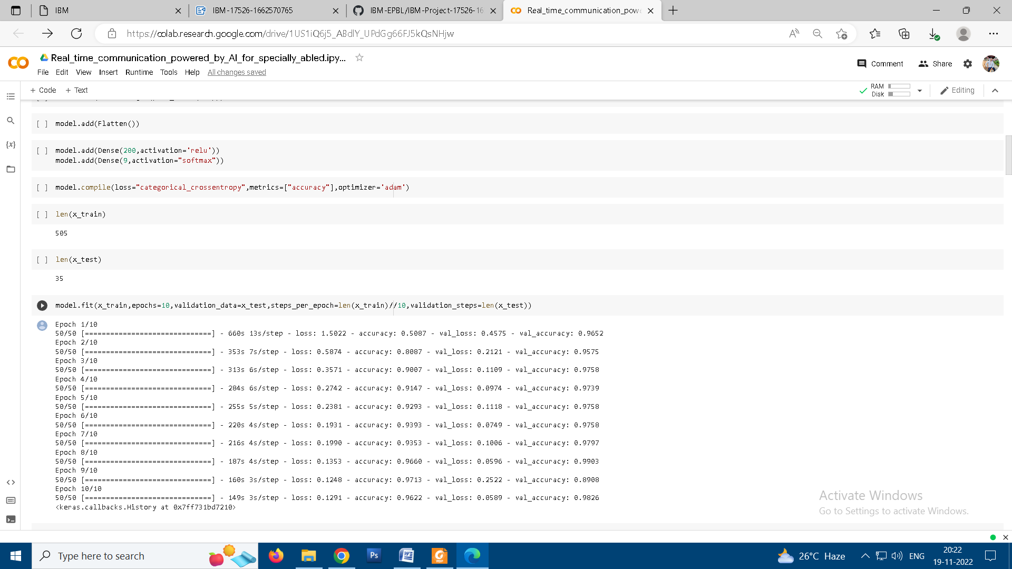

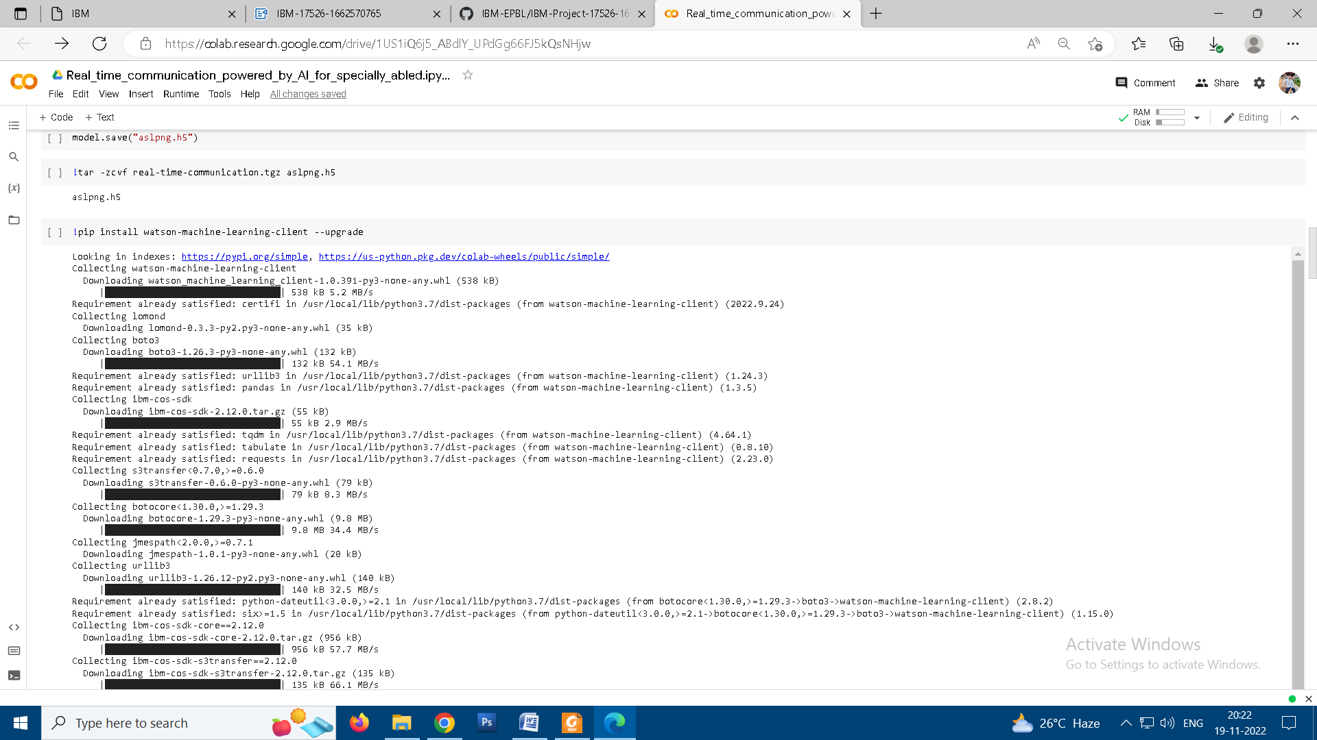

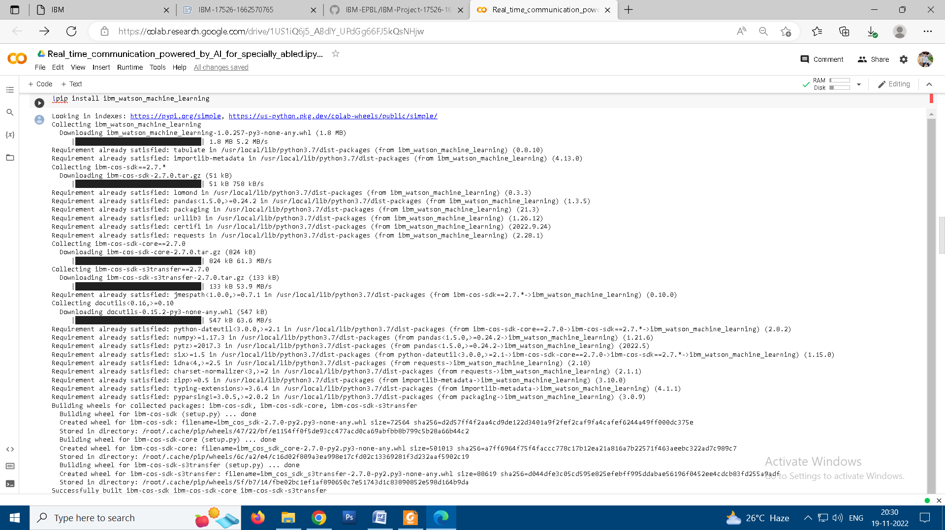

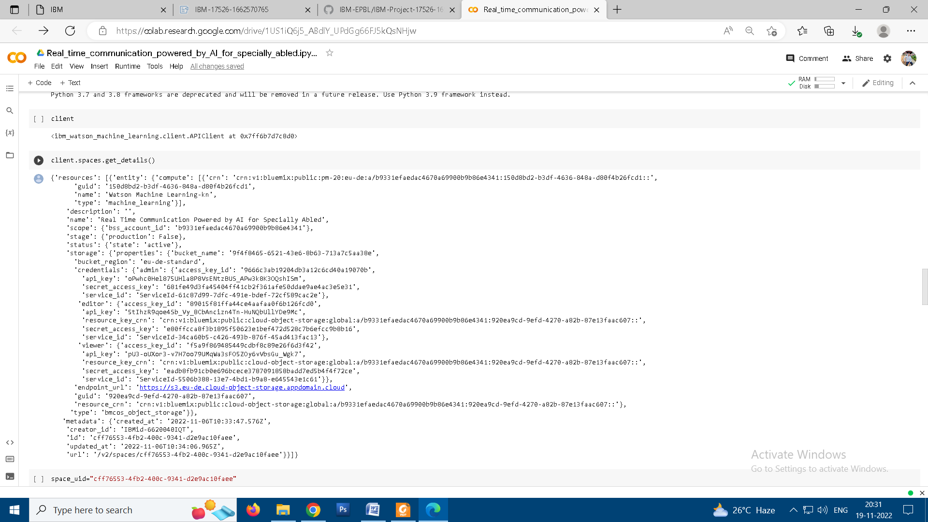

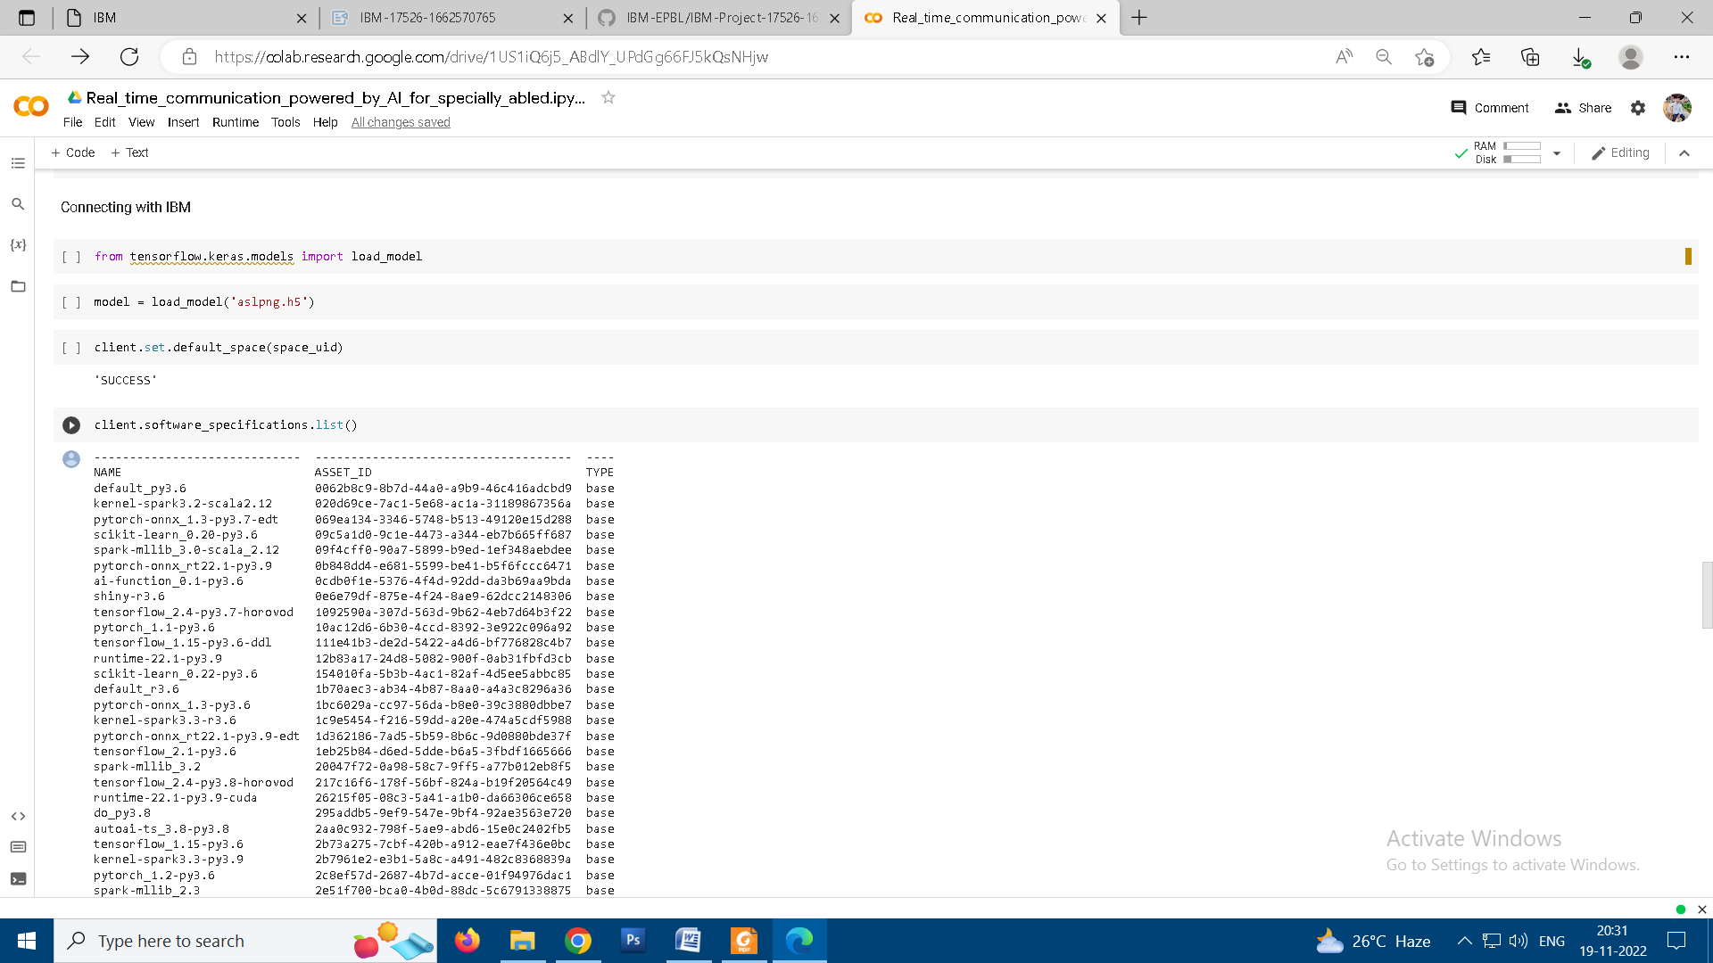

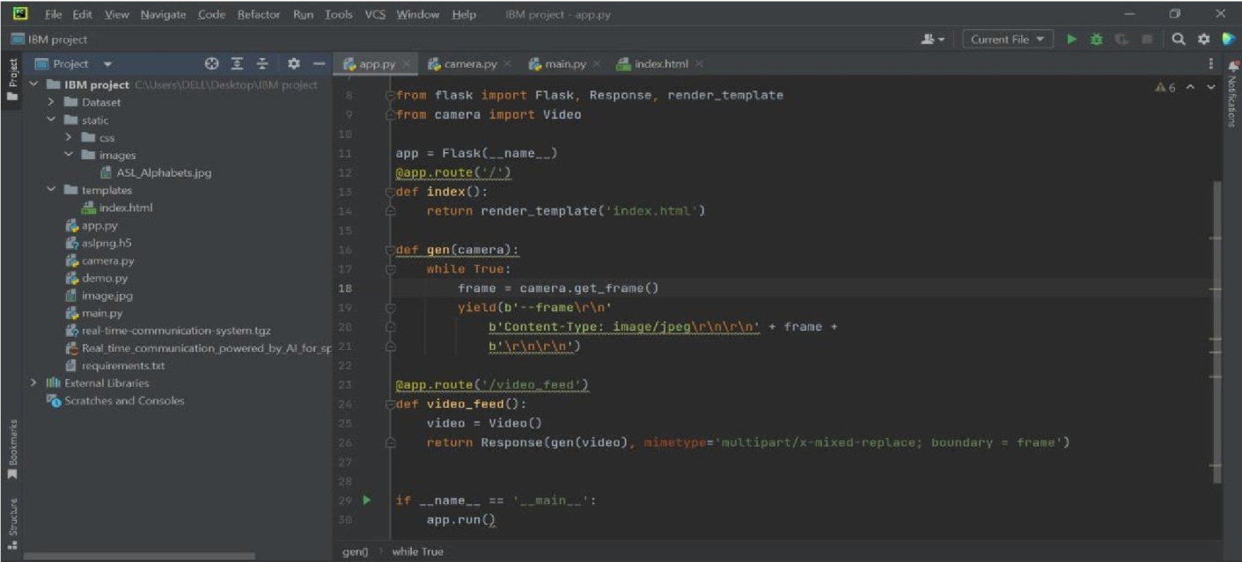

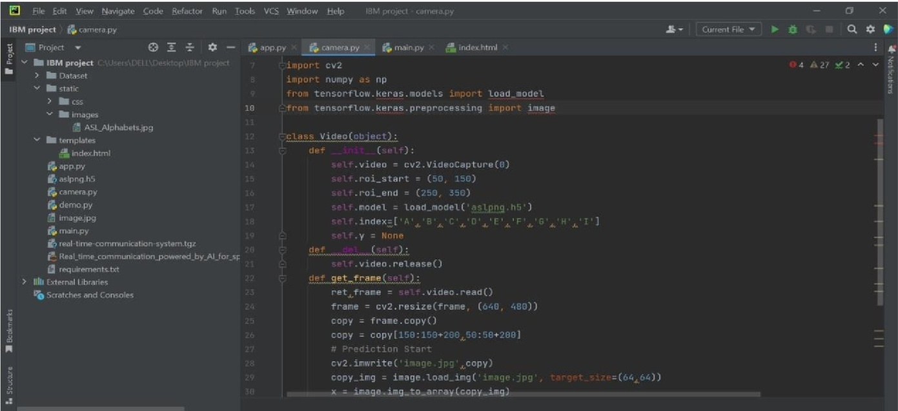

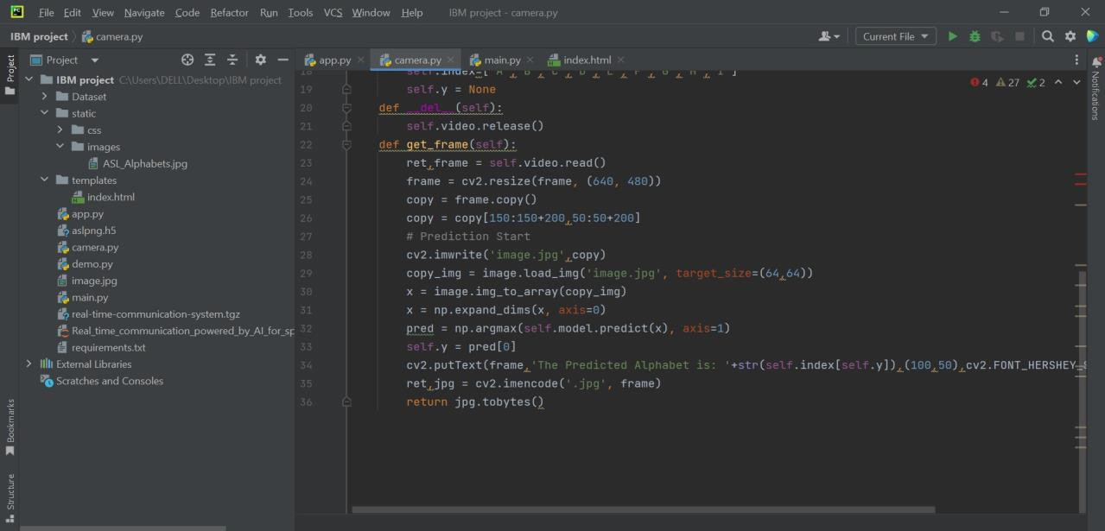

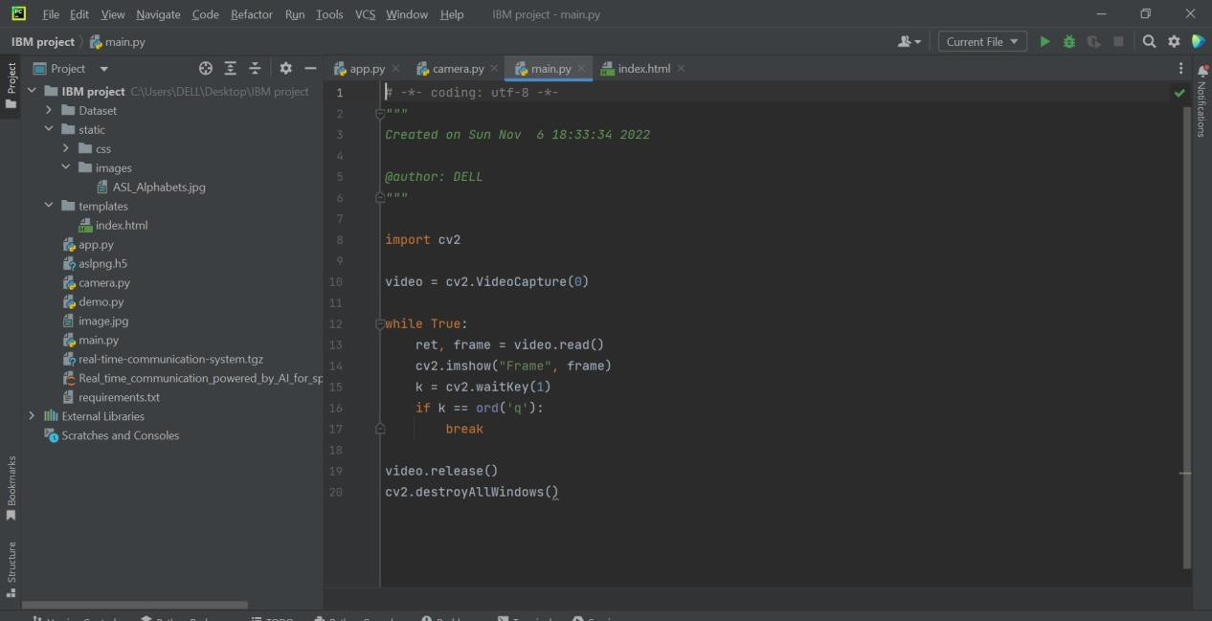

**GITHUB LINK -** [**https://github.com/IBM-EPBL/IBM-Project-17526-1659672954**](https://github.com/IBM-EPBL/IBM-Project-17526-1659672954)

**DEMO LINK** [**-**](https://drive.google.com/file/d/1B-jL8UkxQey9LOrQmDsPpMSZnj0-F4a5/view?usp=sharing) <https://drive.google.com/file/d/1rxp5zxgDTna5xNQsm_BB7GO_wUGug6G7/view?usp=sharing>